The Basic Principles of Pacemaker Operation

Pacemakers are compact medical devices implanted under the skin, usually in the chest, to help regulate abnormal heart rhythms called arrhythmias. They consist of a pulse generator, one or more electrodes, and a battery. The generator monitors the heart’s natural rhythm via the electrodes and sends small, controlled electrical impulses to stimulate heart contractions when needed, ensuring a steady heartbeat. Most modern pacemakers use “demand pacing” where the device only activates when the heart’s rate drops below a programmed threshold. Pacemakers deliver a small electrical current to myocardial cells. As each cell is electrically activated, it contracts. (Ref: https://www.nhlbi.nih.gov/health/pacemakers/how-it-works)
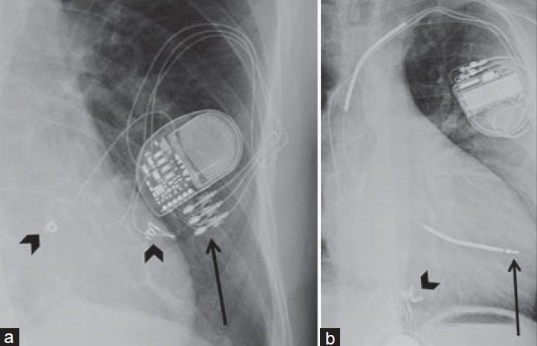Fig: An accurate diagram of a cardiac pacemaker
Source: https://pmc.ncbi.nlm.nih.gov/articles/PMC4286824/
Capacitors: The Heart of Energy Storage in Pacemakers
- Capacitors inside a pacemaker are critical for energy storage.
- They rapidly accumulate and discharge the electrical energy required to send pulses that reset the heart’s rhythm.
- These components must charge and discharge billions of times over the pacemaker’s lifetime, making them essential for reliable device operation.
Researcher Minh Duc Nguyen explains, “It needs to keep up with your heartbeat, so it should be able to charge and discharge up to billions of times. Otherwise, you’ll have to replace the pacemaker every few months.” Modern designs use high-density capacitors that are efficient, durable, and able to operate within the body’s temperature range for years. (Ref: https://techxplore.com/news/2024-04-storage-efficiency-durability-capacitors.html)
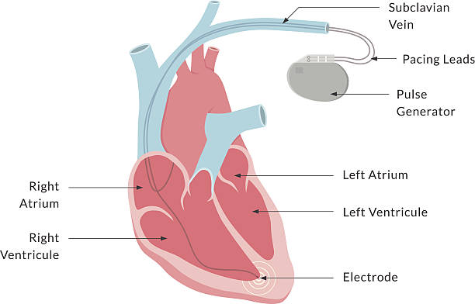
Fig: Close-up illustrations of pacemakers
(Source: https://www.istockphoto.com/photos/pacemaker-battery)
Types of Capacitors Used in Medical Devices and Their Selection Criteria
Medical devices including pacemakers rely on specific types of capacitors chosen for safety, reliability, and long life. The most common are Tantalum Capacitors and Multilayer Ceramic Capacitors (MLCCs). Tantalum capacitors offer stable performance and low leakage current, while MLCCs are valued for high capacitance and reliability. Other types in use include ceramic, film, aluminum electrolytic, polymer, and even silicon capacitors—each picked for attributes like stability, low ESR, longevity, and safety over years of operation. “C0G/NP0 ceramic capacitors are known for their high stability and low loss. They are ideal for implantable medical devices like pacemakers…due to their reliable performance in a wide temperature range.” The selection depends on factors such as biocompatibility, temperature tolerance, physical size, and operational lifespan. (Ref : https://passive-components.eu/capacitors-for-medical-applications-component-selection-considerations/)
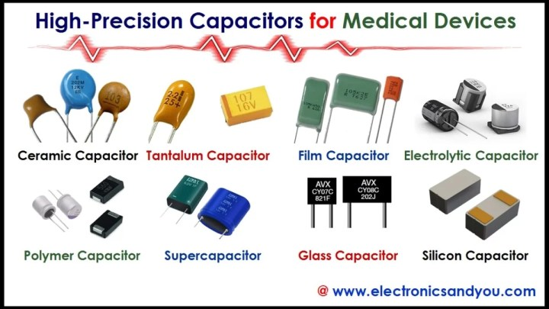
Fig: Comparative images display the shape and construction of diverse capacitor types.
(Source: https://www.electronicsandyou.com/top-10-high-precision-capacitors-for-medical-devices-and-their-applications.html#google_vignette)

THISMAILISCONFIDENTIAL •. THISMAILISCONFIDENTIAL •. THISMAILISCONFIDENTIAL •. THISMAILISCONFIDENTIAL •.

Talha Faiyaz | Platform Executive​
Sugary LLC | talha@sugary.ae
Support: +971 (52) 660 49 52 | Schedule Meeting
WWW.SUGARY.AE

